# Video links

video1: https://youtu.be/fDODh7Ne2Ww

video2 https://youtu.be/3Dt_orPGZBo

video3 https://youtu.be/c0jOlM5yByw

video4 https://youtu.be/Wd7uothcx5g

video5 https://youtu.be/1qnCiEYdnNM

video6 https://youtu.be/b7f0Ih1NbRE

video7 https://youtu.be/R_QOLIQzI-0

video8 https://youtu.be/_LnMghwJ-fQ

video9 https://youtu.be/r7Cm_NU_G9A

video10 https://youtu.be/fRJMuZ8kc-8

video11 https://youtu.be/rqcU0U7bLpg

video12 https://youtu.be/q89pJQbkMY8

video13 https://youtu.be/zzCKlwdL4gI

video14 https://youtu.be/ogho-EdDhbc

video15 https://youtu.be/0ZGocgcB4mU

video16 https://youtu.be/XtjhO6uHISc

video17 https://youtu.be/-Bjzu0JdDAQ

video18 https://youtu.be/gyp-BuoqeUw

video19 https://youtu.be/ciB0wpFH1nA

video20 https://youtu.be/KaLaibD4OP4

video21 https://youtu.be/54QVrK-6vw4

# Derivatives

Chapter 1:

Link: https://youtu.be/fDODh7Ne2Ww

Derivatives are the elements that derive their value from their underlying asset

Below are the examples:

1. A 10₹ note and 2000₹ are of same material, but the RBI governor sign on it is indicating that the 2000₹ note is of 2000 value differentiates 10₹ and 2000₹. HERE THE SIGN IS THE DERIVATIVE AND POWER OF RBI GOVERNER IS THE UNDERLYING ASSET
2. In a contract of land buying. The sellers sign on the contract paper for advance (token amount), acceptance will stop seller from selling the land for a certain period of time (as per contract) and gives buyer to buy the land at a same price for a certain period of time, meanwhile seller has the edge of taking the token amount as profit if the seller is not able to provide the money in stipulated amount of time. HERE THE SIGNATURE IS THE DERIVATIVE AND THE OWNERSHIP OF LAND (THE SELLER HAS) IS THE UNDERLYING ASSET

## Categories of derivatives

Derivatives are categorized in to 4 types

1. Forwards
   1. Physical contracts that are generally used in everyday life, stock markets use their next version FUTURES
2. Futures
3. Options
4. Swaps

Expiry in futures is categorized in to 3 types:

1. Near
   1. If you are in OCT 2022 and if you buy ICICI future contract of the same month i.e., ICICIBANK OCT FUT, then that is called Near expiry
2. Next
   1. If you are in OCT 2022 and if you buy ICICI future contract of the next month i.e., ICICIBANK NOV FUT, then it is called next expiry
3. Far
   1. If you are in OCT 2022 and if you buy ICICI future contract of the month after the next month, i.e., ICICIBANK DEC FUT, then it is called far expiry

# What are Futures

Futures is also a contract, like other contracts has an expiry date, futures also has an expiry date.

You can buy/sell futures

## What is a lot size?

A lot size is the measure for a future scrip contract, a lot size can be better explained with banana analogy: we can buy banana’s in dozen, whereas one dozen of bananas =12. Similarly we can buy future scrip in lots

### Points to note:

All scrips does not have same lot size, in general scrips of higher share price will have less number of units as lot count, scrip price is inversely proportional to lot size (because at the time of writing of this document SEBI had put a restriction that a lot size should not cross a particular threshold, so to obey that rule, scrips of higher share price has to maintain less number of quantity in LOTS, see the below example for more info)

|  |  |  |  |
| --- | --- | --- | --- |
| scrip name | scrip price | lot size | price required to buy future of scrip = scrip price * lot size |
| tata motors | 409 | 1425 | 582825 |
| TCS | 3163 | 150 | 474450 |

## Is it mandatory to have the above-mentioned amount?

No, it is not required to have all amount before expiry, you need to have the amount mentioned by the broker, **but on the date of expiry you need to have the amount if you want to proceed with the contract, more details on this will be covered in the later parts of this documentation.**

## How do future prices increase or decrease?

If the underlying scrip price increase, then future price increase, and vice-versa with price decrease (with a few variables (like gamma, theta, Vega and delta) involved).

## Why are Futures used (for whom was it intended, and who are using it now)?

Futures are introduced for hedging

### What is hedging?

Hedging means **protect oneself against loss on (a bet or investment) by making balancing or compensating transactions.**

### How is hedging needed in stock market- an analogy

#### How investors are meant to be using it

Let’s say you are holding 3000 tata motors shares and the company is going to post its quarterly results in 3 days, all other automobiles companies posted bad results, therefore you are thinking that tata motors is also going to post results on similar lines with other automobile companies, which will lead to loss of your portfolio value, but you already know that tata motors is a good company with strong fundamentals, and the fall in share price is going to be temporary, so instead of selling your 3000 tatamo shares (which might lead to charges and other headaches), you can sell 2 lots of tatamo future scrip and buy them later at a fallen price, therefore the price fall in your original shares is covered up by the future lot you sold, a brief calculation is below

|  |  |  |  |  |  |
| --- | --- | --- | --- | --- | --- |
| **scrip name** | **scrip price** | **shares held** | **price required** | **fall in price** | **loss incurred per share** |
| tata motors | 409 | 3000 | 1227000 | 80 | 240000 |
|  |  |  |  |  |  |
| future scrip | scrip price at which you sold | lot size | lots held |  |  |
| tata motors nov | 409 | 1425 | 2 |  |  |
|  | scrip price at which you bought (409-80(loss incurred per share)) |  |  | profit occurred | |
|  | 329 |  |  | 228000 |  |
|  |  |  |  |  |  |
| loss minimized because of hedge: | loss without hedging | = loss incurred per share -profit occured |  |  |  |
|  | 240000 | 12000 |  |  |  |
|  |  |  |  |  |  |

#### How are traders using it?

##### For selling

Actually you cannot carry a sell position in the normal scrip for more than one trading day, but traders who are sure that a scrip is going to fall, will **sell** the future scrip and **buy again at a lower price** to take profits, but there is a **downfall to it** as well, if after selling the scrip, if the scrip starts going up instead of falling down, then trader has to pay extra amount (which will be his loss), vice a versa applies for buying as well

##### For buying

Traders who are sure that the scrip is going to go up and they think they need to buy more with the less amount, they have, they will **buy** the scrip and **sell** later again at a **higher price**

#### Why traders prefer buying futures and options (FNO) rather than buying/selling actual scrips

Buying/selling actual scrips require more money and also selling actual scrips can’t be more than one day(in delivery or intraday)

If you are buying 1500 shares of tata motors, you need 6,00,000

But to buy FNO contract you need around 40% of 6,00,000

### What happens if buyer/seller holds his future scrip till expiry

Theoretical explanation

From seller point of view:

On expiry he has to give the lot (number of shares) to the buyer and receive share price*lot amount

From buyer point of view

On expiry he has to give money to seller and has to get shares in return

Example explanation:

Contract name: OCT 2022 SBI FUT contract

Price: 310

Lot size: 3000

If a seller and buyer are involved in contract, then

buyer has to give 3000*310 = 930000 rupees to buyer even **if sbi share price is 400 or 200 or 0**

seller has to give 3000 shares (lot size) to seller and receive 930000 from seller **irrespective of share price**

#### What if seller does not maintain shares or buyer does not have enough money in their account:

The broker will check for relevant requirements 2 or 5 days before and will try to inform you over call or other communication channel and then square off the position in case you don’t have needed requirements

## Other advantages of Futures

Chapter 2: Video link: https://youtu.be/3Dt_orPGZBo

Not only stocks, we have metals, Agri commodities, crude oil and water also have Futures

Let’s take the example of gold and try to explain it with an analogy

### An question here: How do gold shops make profit?

We are generally under the assumption that people involved in gold business try to buy bulk gold, when the price is cheaper and make ornaments and sell them. BUT WE ARE WRONG…

There is a saying **only two people know top and bottom of the market, GOD and THE LIAR. AND trying to time the price is similar to GAMBLING, because price depends upon various factors, let’s say the price of gold is X, if the next moment America declares war on Russia, the gold price might become 2X, if the india discovers a gold mine which is almost equal mining of gold that is discovered till date, then the gold price might become X/2**

I am fairly fantasizing the example, but only **a idiot does business on speculation**

**So, coming to the question again how does jewellery companies do business?**

They just make profits on the making charges, then how do they maintain same profit on fluctuating prices (if they bought gold at 100 rupees and making charge is 10 rupees so totally it is 110, if the next day gold price falls to 80 rupees, then they cant sell it at 110 because people wont buy gold if it is sold at a higher price, so they have to sell at 90 rupees (80 rupees gold price + 10 rupees making charge) but if they sell at 90 they are at effective loss of 20), the ANSWER is FUTURES OF GOLD,

If they buy 1kg gold at x rupees, then they will sell futures of 1kg gold at x rupees, so that if the price increases the future contract they sold will be at loss, but the value of the gold they are holding will increase. So now if they maintain healthy margin of making charges, they can be profitable all the time.

### Why should people deal with futures of metals or commodities or oils

Crude oil is needed for paint companies, tyre companies

Metals are needed for automobile companies, infra companies

Commodities are needed for countries

**Apply the same logic of above gold example to all these scenarios**

### When should you deal with futures

You should be dealing with futures in three scenarios

#### Scenario 1- if you have already bought the stock and you need to protect from future fluctuations

If you **buy** x amount of an item at y price, then **sell** same amount of futures of the same item at the Y price

#### Scenario 2- if you don’t have the item with you and you want to protect yourself from future fluctuations

if you have money, but if the commodity is not available then you can **buy** required amount of commodity **future** prices at current time

#### scenario 3- if you want to speculate and earn money

you can sell futures, if you think corresponding commodity price is going to fall, then **selling** commodity futures, and **buying** if Vice a versa happens

## Expiry

There are two types of expiries based on duration

### Weekly expiry

Available in Options (that too only for Indexes like Nifty, BankNifty)

When do weekly option contracts expire?

Weekly contracts expire on Thursday, if it is a holiday, then working day before that Thursday will be the expiry day.

### Monthly expiry

Available in both Futures and Options

When do Monthly option/futures expire?

Monthly contracts expire on last Thursday of the month, if it is a holiday, then the working day before that Thursday will be the expiry day

## spot price, future price

the price of the underlying asset is called **spot price**

the price of a future contract of the underlying asset is called future price

## settlement types

there is 2 types of settlement available

### Cash settlement

Before July 2018, cash settlement is an option, in cash settlement, lets assume

1: you bought tatamotors future contract on 4th nov 2022 at 330 and expiry is at 24th nov 2022 and you held it till expiry and at expiry the price is 340, 10₹ profit*lot size(5700) = 57000₹ will get credited to your demat account

2: you sold tatamotors future contract on 4th nov 2022 at 330 and expiry is at 24th nov 2022 and you held it till expiry and at expiry the price is 340, 10₹ loss*lot size(5700) = 57000₹ will get debited to your demat account

### Physical settlement

From July 2018, sebi implemented physical settlement in order to avoid speculation(of people wantedly buying contracts and then settling in cash (as it requires only less money)), in physical settlement, **if you are a buyer- you need to have required amount (future price* lot amount) to hold the contract till expiry, if you are a seller- you need to have required amount(number of lots*lot size) of shares in your demat**

let’s assume

1: you bought tatamotors future contract on 4th nov 2022 at 330 and expiry is at 24th nov 2022 and you held it till expiry and at expiry the price is 340, you need 330 (buying price) *5700 = 18,81,000 in your account to carry it on till expiry, if the required amount is not there in your account a couple of days (time frame is decided by the broker or exchange(ex:NSE)) before the expiry then your contract will get squared off (sold or exited)

2: you sold tatamotors future contract on 4th nov 2022 at 330 and expiry is at 24th nov 2022 and you held it till expiry and at expiry the price is 340, you need to have 5770 shares at 330 rupees in your demat a couple of days (time frame is decided by the broker or exchange(ex:NSE)) before the expiry then your contract will get squared off (sold or exited)

### Types settlements for different instruments

Equity -> physical

Index -> cash

Commodities -> physical for few, cash for few

Currency -> cash

## margin and settlement concept

margin – how much amount is needed to buy/sell a contract or instrument

### how much money we need to buy/sell futures

delivery (NRML margin), intraday types

Buying and selling of future can be of 2 types

1: **Delivery (holding for more than 1 day)**

2: Intraday (holding for one day)

Money that we need to buy/sell a contract is **same for both intraday and delivery**. The amount that needs to be there to buy them will **slightly differ from broker to broker**

You can get the details of the amount needed by your broker by googling the “<broker name> margin calculator” ex link: <https://zerodha.com/margin-calculator/SPAN/>

### how profit/loss or settled in futures

profit/loss settles on day-to-day basis

let’s say today is 6th November 2022. And 7th you bought a future contract and you don’t have any balance left in your account

|  |  |  |
| --- | --- | --- |
| date | profit/loss | cumulative profit/loss in your account |
| 07-11-2022 | 10000 | 10000 |
| 08-11-2022 | 15000 | 25000 |
| 09-11-2022 | -40000 | -15000 |

If by 9th November 2022, if you don’t maintain 15000 in your account so that the broker than settle your 15000 losses, then you will attract extra penalty and broker gets the right to terminate your contract altogether.

Doubt: does the contract gets squared off the next day we does not maintain balance, or does it wait till the contract expiry? #need_clarity  
I think the contract gets terminated the next day

It is always suggested to maintain 50% of the contract value as an additional bonus to avoid the beginners mistake of attracting penalty

## Future Pricing or option pricing (V imp topic to read)

Future price is proportional to the remaining days of expiry

the price of the current month contract < price of next month contract

### formula to calculate ideal future pricing

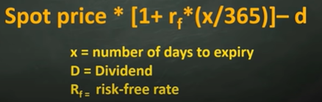

#### Why this formula is of less relevance/importance

No matter how much you calculate, you are ultimately going to buy at the price which is available in the market

Also, there are very big people with most advanced systems and more professionals looking at these and trying to get them at the best price, the goal as of now for us will be to just focus on the initial earnings and then to focus on these types of things later

**Most of the times, The price that is there in the market- it is there for a reason and the price always tries to find its balance, so don’t give much importance(but give importance it deserves) to the price**

### Factors influencing contract price

1. Number of days left till expiry – **spot price>near expiry>next expiry>far expiry**
2. Dividend – if a company gives dividends, that’s deducted from stock price, then you also have to deduct it from future contract price
3. Market sentiment – if there are bullish sentiments, then buyers increase, therefore prices of stocks and future contracts increase, vice-a-versa for bearish contract

#### When does future price<spot price

1. When there is a dividend announced formula
2. When there is panic in market (#need_to_check_in_realtime – what happens to future/options contract when if its underlying scrip touches lower circuit)

# Options

Chapter 3: Link: https://youtu.be/c0jOlM5yByw

## Why should we learn options carefully

**Options is important** because 85% of the profit comes from options, **options is dangerous** because 90% of the traders like us lose money in options

## What is call or put

If you think market/particular stock option is going to increase, then you will **buy** call option

If you think market/particular stock option is going to decrease, then you will **buy** put option

**call buy option contract movement is indirectly proportional to put buy option contract movement, and vice-a-versa applies for sell as well**

**in call or put buyer will have the right and can demand seller (prathi sari call/put buyer domination ey)**

* **In call – to buy shares from seller at a fixed price (a call buyer will use this when the shares go up in real market and he will buy shares from seller at a pre-fixed lower price)**
* **In put – to sell shares to buyer at a fixed price (a put buyer will use this when the shares are falling and he wants to sell shares at a pre-fixed higher price)**

### Relation between spot price (it is stock price), future price, call price and option price

Spot price is directly proportional to future price and call price

Spot price is indirectly proportional to put option price

### When to buy what

If you think a stock is going to go up, then

1. Buy that stock or
2. Buy that stock’s future option
3. Buy that stock’s call option
4. Sell that stock’s put option

If you think a stock is going to go down then

1. Sell that stock or
2. Sell that stock’s future option
3. Sell that stock’s call option
4. Buy that stock’s put option

## What process happens between an option buyer and option seller during a **call** transaction

Before we understand, what happens between a buyer and seller, let us go through an analogy

### An analogy

Lets say there is a land, and there is an insider speculation that a ring road is coming near it, so you go to the land owner and say let us make an agreement for 5 months, I am giving you a **token amount** of 10,000 if I come within 5 months and ask you for this land you should sell me at a fixed price of 50 lakhs, if I don’t come within stipulated time, you can keep the token amount and sell it to someone else at the price of your wish

### Real time example

Let’s say there is tatamotors spot price at 330 and you buy call option tatamotors 330 CE (call option) at 15 rupees (**premium**), then you have to pay 15*5700 (lot size) = 85500 to seller so that **seller will offer the 5700 tatamotors shares at 330 rupees on expiry,** because **option buyer has the right to ask shares at the prefixed rate, but seller cannot force buyer to buy the stocks**

If anyone is buying the option tatamotors 330 CE (here strike price of the contract is 330), then he/she is under the assumption that the stock is going to go up, if anyone is selling the option tatamotors 330 CE, then he/she is under the assumption that the stock is going to go down or will be staying at 330 or 330+premium price range

### Different types of cases (possibilities) **on expiry day**

Lets say seller sold tatamotors 330 ce to buyer at 15 premium

|  |  |  |  |
| --- | --- | --- | --- |
| case | Buyer at | seller at | explanation |
| if expiry happens at 330 | loss | profit | if the expiry happens at the same price of the contract, then the buyer can get the stocks from open market at the same price and then the seller can have the token amount(15*5700), the buyer loses the token amount |
| if expiry happens at 330+premium(15) i.e, 345 | no loss | no loss |  |
| if the expiry happens above 330+premium(15) i.e., 350,360… | profit | loss | the profit for the buyer is (expiry price - (entry price + premium)) * lot size |
| if the expiry happens below 330 i.e., 280,260… | loss | profit | Token amount 85500, because the buyer does not have any mandatory rule to buy, he can buy if he wants, but no buyer wants to buy at loss, **he will buy shares in open market** |

The seller utmost can have the token amount as profit (because if the price happens to fall below the contract, the buyer will forgo the token amount), but the buyer can have utmost profit because, if the contract happens at 330 and the stock price goes to 1000 or even more before expiry, still the seller has to sell the lot at 330 per share, which is a loss to seller but unlimited profit to buyer

Risk profile

Buyer- risk limited, profit unlimited

Seller- risk unlimited, profit limited

### Important point to note

In the above discussed table **we discussed all scenarios at expiry date,** in all the above scenarios buyer has only one scenario where he gets profit

**But is it the only case where buyer gets profit?**

**No, there is another scenario where the option buyer can have profit**

let’s say the buyer has purchased tcs 3500 ce at 5 premium, the next day underlying stock moved up because of some positive news, then let’s say premium moved up to 10, then [(current premium - buying premium)*lot size] (10-5)*200 will be the profit

**an option buyer in general will be profitable when he can sell his (already bought) contract at a price higher than what he bought**

## put and call

Chapter 4: link <https://youtu.be/Wd7uothcx5g>

#### what is put

if a option trader thinks that market/scrip is going to fall, then he will buy a put contract

##### a put option buyer is in profits when

when stock price goes down, the put option contract price goes up, he will be in profit

##### a put option seller is in losses when

when stock price goes up, the put option contract price goes down, he will be in loss

#### difference between put and call

similar to the process of having contract (a direct relationship) of call, **put** also **has** a **contract, but the contract formation in put (indirect contract) is a bit different**

for more details on call contract go here

##### an example

lets take tata motors share, its trading price is 330 ₹, we will take put contract tatamotors 330 pe, lot size 5700 expiry is 25 February

**if you have 5700 tatamotors at 330 rupees. shares and you think that tatamotors shares is going to fall, then you have 2 options**

1. Selling 5700 shares of tatamotors
2. Buying the tatamotors 330 pe option

Let’s say that you have gone with the second option of buying tatamotors 330 pe, so the **seller is giving you the guarantee** **that even if the tatamotors go to 1 rupee then as well seller will take your 5700 shares of tatamotors at 330**

###### What happens if tatamotors share is at contract price (330) or above contract price (340 or 350 or 360…) or below contract price (i.e., less than 330) on expiry

If the scrip is on or above contract price (330) on expiry then:

Then the option buyer **will not** **go to seller and ask him to buy his stocks at price (330 or 340 or 350…),**

If the scrip is below contract price (330) on expiry then:

**Seller has to buy at 330 from you for sure**

###### What happens in a typical put contract transaction at the end of the expiry

contract Seller will give you guarantee that he will give 5700*330₹ and take 330 tatamotors shares from contract buyer

#need_to_check_in_realtime – if a stock price falls by 100 rupees how much does it changes in option prices w.r.t the price we bought it

Ex: if **tatamotors at 330 rupees.** If you buy tatamo 330PE at 5 rupees premium, then what will be your profit if share falls by 100 rupees

##### comparison of share transfer between put buyer and put seller, call seller and call buyer

pe buyer **sell** stocks to pe seller

ce buyer **buy** stocks from ce seller

##### v v v v v imp (in regular income strategies)-main differences between put and call

###### in trading point of view (POV)

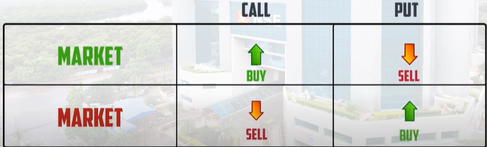

###### v v v v v imp –In buyer and seller POV

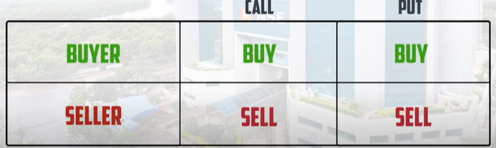

A buyer buys call option when he doesn’t have the stocks and thinks the stock will go up in future or if you know that the stock will go up and you want to buy the stock at current price

A seller who sells call option has already stocks with him and sells stocks to buyer who is ready to get stocks at a premium or when a seller who thinks the stock is going down, but he doesn’t have enough money to buy lot of shares

A buyer buys put option when he has stocks and thinks stock will go down and he wants to set a price and sell stocks at that price

A seller who sells put option will be ready to buy stocks from buyer

In a nutshell

In call option - a buyer (has the right to) buys the stocks (at a prefixed rate) and a seller sells the stocks

In put option (it is kind of reverse) - a buyer (has the right to) sells the stocks (at a prefixed rate) and a seller buys the stocks

An example scenario when does a call and put option buyers make profit and when does a call and put option seller make profit

Let’s take 330 ce as call option and 330 pe as put option, both are with 5 premium

A call option buyer makes profit when call option closes above 335 (330 strike price + 5 premium) on expiry

A put option buyer makes profit when put option closes below 325 (330 strike price – 5 premium) on expiry

A call option seller makes profit when call option closes below 335 (330 strike price + 5 premium) on expiry

A put option seller makes profit when put option closes above 325 (330 strike price – 5 premium) on expiry

From 10:20 I did not understand what he is saying- satya needs to explain

# Similarities between futures and options

* They have same lot size
* They almost have similar settlement with slight variation
* Both have OI

# Difference between futures and options

|  |  |
| --- | --- |
| **futures** | **options** |
| will have one contract per unit of time, tatamotors FEB FUT | will have multiple conracts for a single scrip for a particular unit of time, ex: tatamotors feb 440 CE, tatamotors feb 450 CE, tatamotors feb 440 PE, tatamotors feb 450 PE |
| price will have almost similar to -> scrip price+(demand and supply value), ex: tatamotrs share price is 418, tatamotors feb fut value is 421 i.e., 418+3 (demand and supply related value) | price of option contract depends on its nearness to the option price and number of days left to expiry, tatamotors FEB 310CE has 114 rupees and tatamotors feb 320 CE has 95 |
| IMO, can be best used for hedging | IMO, can be best used for speculating/trading |
| buyers/sellers have to definetly perform the contract | buyers don’t have the oblication when they buy CE contracts and vice a versa for PE contracts |

# How to decide Which option to buy- which call or which put?

Chapter 5: Link <https://youtu.be/1qnCiEYdnNM>

We know that if a stock price is going to rise- we will buy call option, if the stock price is going to fall we will buy put option,

But which option to buy, i.e., if the stock is at 330,

1. if it is going up, should we buy 340 ce or 350 ce or 360 ce and so on…
2. if it is going down, should we buy 320 pe or 310 pe or 300 pe

to get these understanding, please continue reading below

## On what does the option premium depend upon

Value of Option premium depends upon **intrinsic value and time value and few other factors**

**Option premium = intrinsic value + time value + market volatility +interest rates (appreciation or depreciation by RBI) + dividends**

**Intrinsic value = stock price ~ strike price (i.e.,** if the stock price is 330 and strike price is 350, then intrinsic value is 20, I think the positivity and negativity of the price depends upon the option type i.e., call or put (more details needed 😊)**)**

**To understand the intrinsic value you need to understand ITM (In the Money), ATM (At The Money), OTM (Out of The Money) (discussed below)**

**time value = number of days left to expiry (directly proportional to option premium)**

**market volatility -> depends on various factors like geopolitical situations, economic crisis**

**you can ignore Interest rates and dividends**

more details here

## ITM, ATM, OTM

**ITM,OTM,ATM will be based on option buyers POV**

### Theoretical explanation of ITM, ATM, OTM for both call and put

Before we go for call and put, lets understand ITM, ATM, OTM

All the contract prices that the stock **has covered** for **is ITM**

The contract which is **nearer to the stock** price is **ATM**

The contract prices which the stock **has to cover** is called **OTM**

#### For call

The price goes up In call, so for the stock to reach 330, it should have covered 280 CE,290 CE,300 CE …325 CE **these are ITM**

the contract **near to the stock price is** 330CE, it is **ATM**

If the stock is at 330CE then it **has to cover** 340CE, 350CE …. These are **all OTM**

#### For put

Quite opposite to put

The price goes down In put, the stock price is 330, it should have covered340PE, **these are 340PE is ITM**

the contract **near to the stock price is** 330PE, it is **ATM**

the contracts that stock price is 330, the contracts 280 PE,290 PE,300 PE …325 PE, these are all **OTM**

### Intrinsic value

#### Intrinsic value of call option:

Let’s say there is a stock and its current price is 300

**A call option contract intrinsic value = stock price – strike price of call option**

Lets take 4 different call option contracts and check their intrinsic value, **intrinsic value cannot be negative, if you get negative intrinsic value** **for a contract, then make it 0**

1. 340 CE its intrinsic value is 300-340 => -40 this contract’s intrinsic value is 0 as it got negative intrinsic value
2. 300 CE its intrinsic value is 300-300 = 0
3. 280 CE its intrinsic value is 300 – 280 = 20
4. 260 CE its intrinsic value is 300 – 260 = 40

##### Important point

Intrinsic value will be positive for ITM contracts

Why intrinsic value will be positive for ITM contracts?

#need_to_write

Instrinsic value will be 0 for ATM and OTM contracts

##### Explanation of ITM, ATM, OTM with an example in **call options**

Let’s take tatamotors with an example, its share price is 320, let’s say call options strike prices are with 5 difference i.e., 315CE, 320CE, 325CE, 330CE

ATM (near to the stock price): contract strike price nearest stock price

320CE is the ATM

**Important point**

if the stock price is 318, the **nearest available** strike price are 320CE,315 CE but 320CE is more nearer

So ATM for this example is 320CE

ITM (Stock price already reached these contracts): strike price < stock price

So ITM contracts are 315 CE, 310CE …

OTM (Stock price yet to reach these contracts): strike price > stock price

So OTM contracts are 325CE, 330CE….

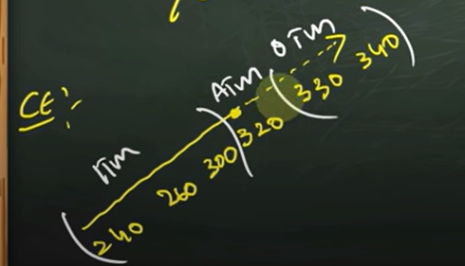

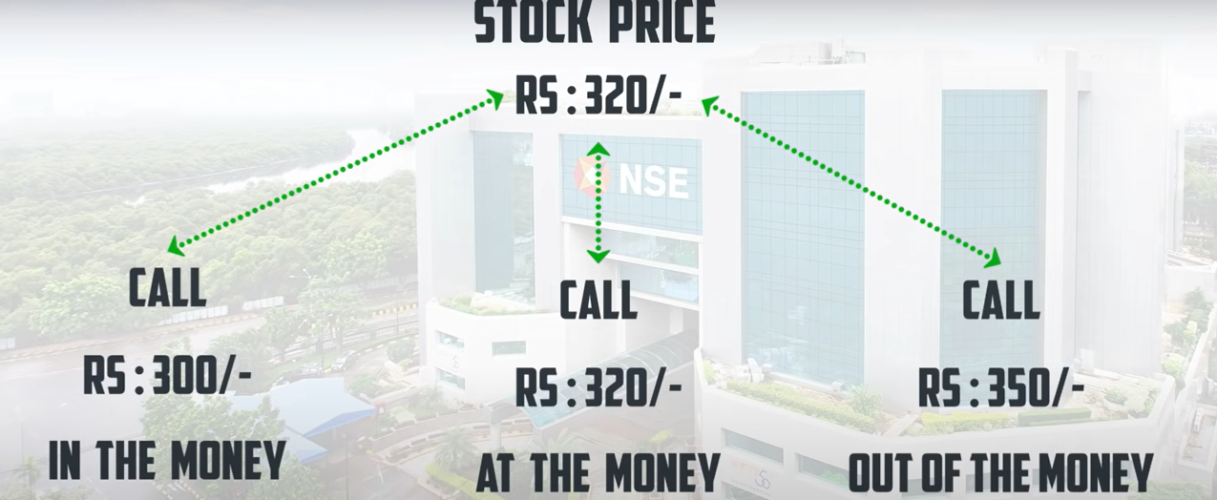

#### Intrinsic value of put option:

Let’s say there is a stock and its current price is 300

**How to derive the formula?**

**As we know ITM should have positive value**

**Lets take an example, if the stock price is 400, then ITM contracts strike prices in put option are 410,420,430…**

**As we can see here that strike price > stock price, therefore in order to get positive value for ITM contracts, we have to strike price-stock price**

**A put option contract intrinsic value = strike price of put option - stock price**

Lets take 4 different put option contracts and check their intrinsic value **intrinsic value cannot be negative, if you get negative intrinsic value** **for a contract, then make it 0**

1. 260 PE its intrinsic value is 260-300 => -40 this contract’s intrinsic value is 0 as it got negative intrinsic value
2. 280 PE its intrinsic value is 280-300 = -20 this contract’s intrinsic value is 0 as it got negative intrinsic value
3. 300 PE its intrinsic value is 300-300 = 0
4. 340 PE its intrinsic value is 340-300 = 40, **but if you bought it at 50 premium and if the stock closed at 300, you will get back its intrinsic value, you wont get that extra 10 rupees as (it is the premium you paid for market conditions or any other factor which you thought**

##### Explanation of ITM, ATM, OTM with an example in **put options**

Let’s take tatamotors with an example, its share price is 320, let’s say put options strike prices are with 5 difference i.e., 315PE, 320PE, 325PE, 330PE

ATM (near to the stock price): contract strike price nearest stock price

320PE is the ATM

Need clarity for below part:

Important point -> if the stock price is 318, the **nearest available** strike price are 320PE,315 PE but 320PE is more nearer

So ATM for this example is 320PE

OTM (Stock price already reached these contracts): strike price > stock price

So OTM contracts are 315 PE, 310PE …

ITM (Stock price yet to reach these contracts): strike price < stock price

So ITM contracts are 325PE, 330PE….

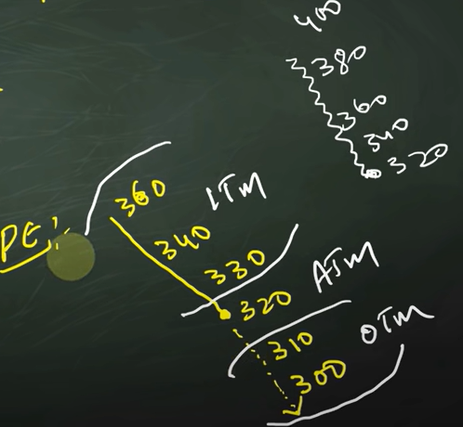

#### Importance of intrinsic value

**After expiry you are left with the amount which is Intrinsic value *lot size**

**Intrinsic value is only there for ITM contracts**

##### What does intrinsic value mean for ITM, ATM, OTM

ITM already **have positive intrinsic value**

ATM **has good chance to gain intrinsic** value (because they have very high chances of becoming positive according to intrinsic value formulas of call and put options discussed above)

OTM (in general bear negative values -10,-20..) has chance of intrinsic value as they need very much positive movement

FAR OTM (a very high negative value -90,-100…) has very less chance of intrinsic value as they need very much positive movement

## How should buyers/sellers decide which to buy

### For buyer

If you are confident go for ITM

If you have normal view go for ATM

If you have no view and you have gut feeling based on some numbers or you got some outsider news that market is going to have good momentum got for OTM (3 or 4 contracts away from ATM these are Hero Zero trades)

Going for deep OTM (10 or 15 contracts away from ATM) is **danger**

### For seller

Let’s take an example of call option, if you are a seller of call option, then that means you think market will fall, if nifty is at 18000CE, ITM will be 17950 CE ATM is 18000CE and OTM is 18050 CE

If you are super confident that market will fall then sell an ITM 17950

If you are confident that market will fall then sell an ATM 18000

If you have neutral view about market sell an OTM 18100 or something around

If you have no view then sell a deep OTM 18500 or something around

In nutshell:

Super confident – sell ITM

Confident – sell ATM

Neutral - sell OTM

No view – sell Deep OTM

# What should we understand before we place stoploss and target for option contracts

Chapter 6- Link:

https://youtu.be/b7f0Ih1NbRE

Revanth bro said that (by seeing chart- which chart exactly? Future chart or underlying scrip chart) it is easy to place target and stop loss for future contracts, I don’t know how please explain MR.satya #need_clarity

To analyse option contracts price movement and also to keep target and SL for the option contracts we deal with, we need to know option greeks

Option greeks are the 5 symbols which act as variables in the price movement of option contracts

They are

1. Gamma
2. Theta
3. Delta
4. vega
5. Rho

We don’t need to consider Rho as it is a variable that relates to interest rates, **we can almost ignore and think that Rho does not exist**

**The order of importance of greek options is as follows**

**Delta>Vega>theta>gamma**

Brokers and other resources displaying option greeks information

1. Upstox
2. Zerodha
3. Sensibull
4. Opstra

## Lets understand delta, theta, vega with an **brief** example

Below is the sample image of options in upstox

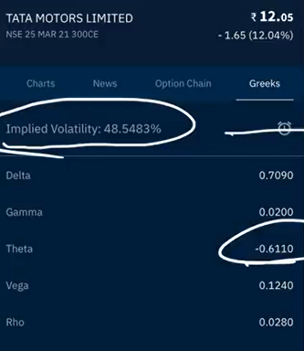

Ex: lets take **tatamotors option contract 300 ce trading with 12 premium**, at the time of this example that **tatamotors share price** is 305

### delta

let’s say Delta value for this example is 0.7090

For every one rupee increase in **tatamotors share price** (i.e., 305 to 306) **tata** **motors option contract 300 ce increases by 0.7090 (considering that, if we ignore all other factors and options)**

### Theta

Theta represents time value

Let’s say theta value for this example is -0.6

the tatamotors share price opened at 305, and had many fluctuations and again closed at 305, then the theta value gets added (if theta is negative, it gets subtracted) to the **tatamotors option contract 300 ce’s premium**

**range bound market lo theta pandaga cheskuntadhi**

**i.e., 12-0.6 = 11.4**

### vega

the movement in **vega is directly proportional** to **Implied Volatility** (It is also seen in option chain data by NSE website)

**implied volatility- is it important? How is it related to vix?**

**Do we need to be seeing video on VIX by revanth brothers?** #need_clarity

Let’s say vega value for this example is 0.2

for every increase 1% of IV, **tatamotors option contract 300 ce’s premium** increases by 0.2

### rho

the movement in **rho is directly proportional** to **interest rates** (It is also seen in option chain data by NSE website)

Let’s say rho value for this example is 0.3

for every increase 1% of interest rate, **tatamotors option contract 300 ce’s premium** increases by 0.3

**rho can be neglected because, interest rates don’t go up/down that frequently**

## detailed explanation of option greeks

## delta

delta is **important** in having success of Option trading**,** so to implement an option strategy correctly, you need a good understanding of delta

example:

let’s say the stock price is 300, and call option contract of that stock 300CE is trading at 5 premium, its delta value is 0.5, the stock price moved by 10 rupees, the call option contract price will be with the formula

updated premium price = existing premium + (delta * price movement)

updated premium price = 5 + (0.5*10) = 10

### 4 types of cases involved from a buyer’s POV (point of view)

1. Moving in the direction of call buyer (a person buys call if he thinks the price is going to go up)
   1. updated premium price (will be higher than existing premium) = existing premium + (delta * price movement)
2. Moving in the opposite direction of call buyer (a person buys call if he thinks the price is going to go up)
   1. updated premium price (will be lower than existing premium) = existing premium - (delta * price movement)
3. Moving in the direction of put buyer (a person buys put if he thinks the price is going to go down)
   1. updated premium price (will be higher than existing premium) = existing premium - (delta * price movement)
4. Moving in the opposite direction of put buyer (a person buys put if he thinks the price is going to go down)
   1. updated premium price (will be lower than existing premium) = existing premium + (delta * price movement)

Note :-

For PE delta will be negative in range 0 🡪 -1

### types of cases involved from a seller’s POV

#need_to_write the same for above 4 points for seller POV

cases involved in sellers POV is opposite to the buyers POV (#need_clarity – need to discuss with chinnodu and write formulas for seller scenarios like above)

### delta values for call and put options for ATM,ITM,OTM

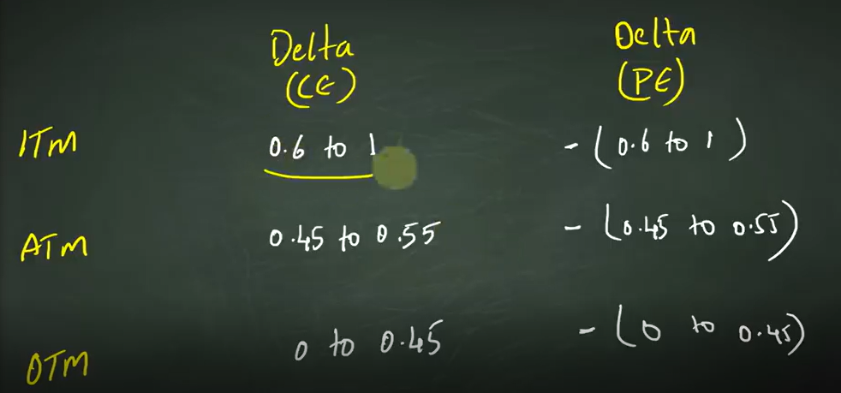

### In a nutshell

Delta value for ce lies between 0 to 1

Delta value for pe lies between -1 to 0

When your view proves to be right, delta value increases

## Gamma

### Why gamma is required to decide delta

An example:

Let’s take tatamotors share. Its current price is 300 and tatamotors 300CE (**which is ATM**) is at 5₹ premium and it’s delta is 0.5 and then if the stock price moves by 10₹ then the **new strike price (premium) = 5 + 10(0.5) = 10,** now comes the interesting point, the contract we bought is 300CE and the share price is 310, now the contract 300CE is ITM, therefore in general ATM contracts premium < ITM contract premium. So therefore should the delta value of the contract should increase or not?

Yes it should increase

But **at what rate?**

At the rate of gamma. To explain it clearly, lets take tata motors at price 300, we bought 300 CE contract at 10 premium , delta as 0.5 and gamma as 0.02

If share price increases from 300 to 350 (we bought CE thinking it will increase, it is moving in the expected direction), then

New premium = 10 + (50*0.5) = 35

As share price is 350, and our contract 300CE becomes ITM, so its delta value should increase

**updated delta value = old delta value + (gamma * points)**

= 0.5 + (50*0.02)

= 0.5+0.1 = 0.6

Note: gamma changes for each point, so rewrute above case with this concept

### When is gamma value added and when it is subtracted?

If the share price moves in the support of our contract type(upside when we bought CE and downside when we bought PE) then gamma value is added to delta, if it moves in the opposite side of our contract type then, it is subtracted

## Theta

If the share price ends in the same level at which it opened, then the premium reduces by theta

**Theta will always be negative**

It is the **biggest enemy of option buyers in range bound**

## Vega

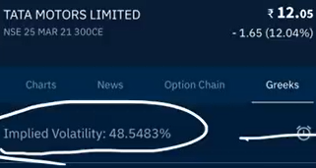

**Implied volatility, option price and vega are directly proportional.**

If volatility increases, then vega increases, then option price increases

If market is volatile downside, then put contracts have higher premiums because of higher vega

More detail on how vega acts as determining factor and calculation of premium price: here

If you are dealing with options, then you are paying a bit of money for IV, when you are buying a contract

## A formula to include Greek options in and calculate/estimate target

Theoretical explanation for the need of **black & scholes** formula

By seeing underlying scrip chart you will be able to guess how much it might go up and what should be stop loss (by doing technical analysis) you can also include delta in predicting, but there are other greek options such as theta and vega which are also to be included while determining the price, to calculate that, there is **black & scholes** formula

This formula is **not exact but approximate**

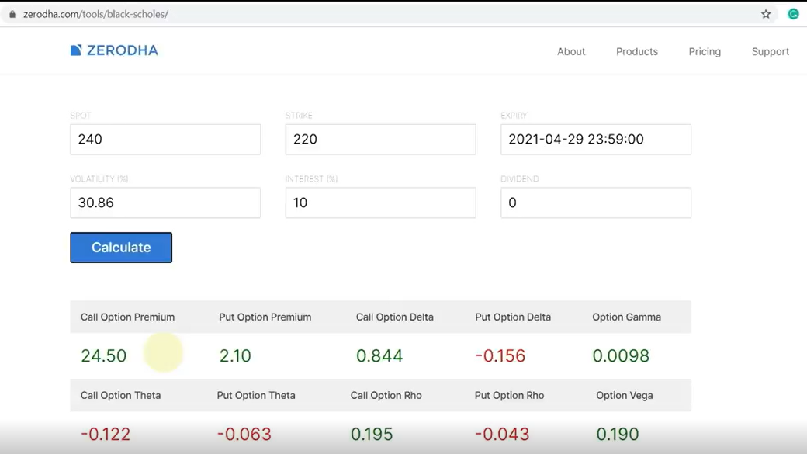

1. spot - the price to which you think the stock reaches
2. strike – the value of option, ex: 220 CE strike is 220
3. expiry – the expiry date of the contract
4. volatility – the IV available in option chain website or upstox
5. interest rate = 10%, because NSE uses 10% as interest rate for computing IV
6. call option premium, if the stock price moves to 240, then our premium becomes 24.5, you can also see other greek options available

### why **black & scholes** formula is not 100% accurate

in the input fields of the formula, you can see that except volatility all fields are fixed, only implied volatility changes due to few reasons and also people decision taking rationale based on market conditions will also differ from time to time

## how theta will keep you in loss even if stock price is moving in the direction, you expected **especially for OTM contracts**

lets say you bought a call option thinking that stock price will increase and the price of the stock is increasing, but increasing at a slower pace, the delta of the contract is 1 and if the **theta** of the contract is 2, for every increase in 1₹ of **delta**, you are actually at loss

so it is important that you need to have ***delta > theta***

## importance of “**EVENTS**” in profitable trading

events are like: rbi meeting, elections, company results

based on the event positivity and negativity premiums go up and down

you need to be careful when you are buying option contracts at or before events

it is better to buy contracts only when you have **higher conviction**, **because premiums will be higher because of the event anticipation and premiums will fall post (some times very fastly) the event**

let’s take an example:

if you have an expectation that **abc company** is going to post bumper results and you bought call option of that company and if the company posts normal results, as soon as the company posts then you can see big drop in premiums

#last_Stopped

# price, Open Interest, Volume

chapter : no mention

7th link: https://youtu.be/R_QOLIQzI-0

**volume**: number of quantities traded, volume is available for stocks, futures and options

when you are checking a stock volume at a given time period (it can be in days, hours or minutes), then it indicates how many stocks/contracts have traded i.e., changed hands (buyers to sellers **or** sellers to buyers)

**Open Interest:** the number of contracts open at a given time in that particular contract

When is a contract said to be open?

In buying POV

A contract is open when a person **A** sells some stock to another person **B**. that contract will be open unless person **A** buys (back) the same stock that he has sold to **B**

**Here person A and person B are said only for example, but an contract is open until the person who sells, will buy back that contract (from any person)**

**Important point to note:**

**There are 3 types of outcomes in OI**

1. **no contracts open at all**
2. **buy contracts open**
3. **sell contracts open**

If a lot of buy contracts are open, then it means people have already bought are holding what they have bought, if buy contracts are increasing, that means people are aggressive towards buying and are likely to buy at a higher price. **It is a bullish sign, vice a versa for sell contracts -> bearish sign**

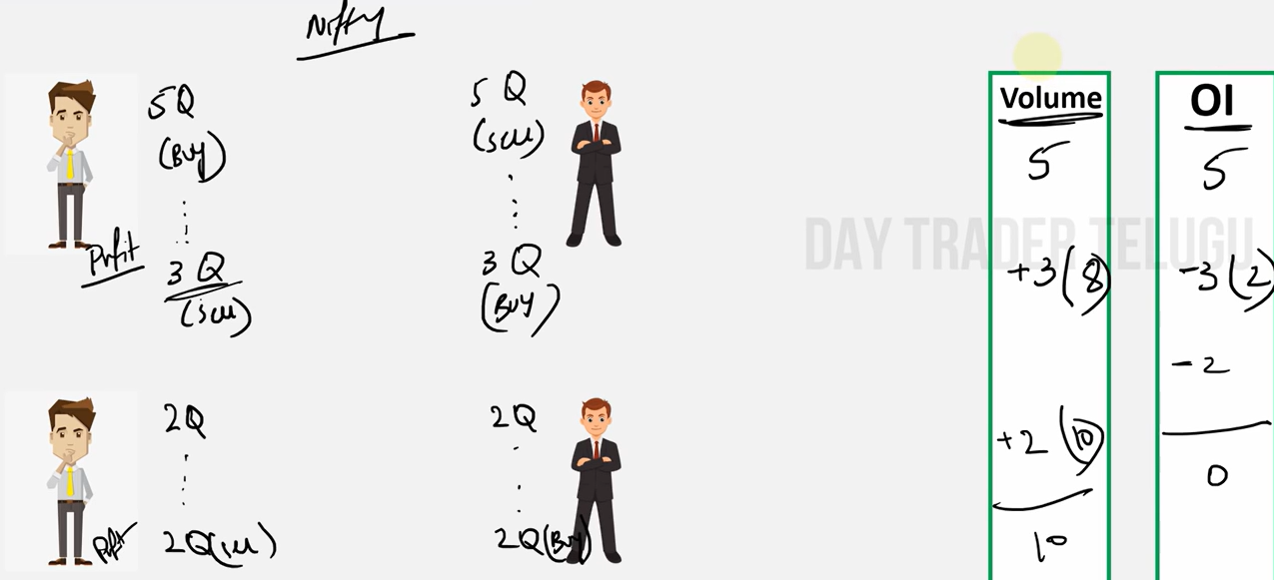

In the above example,

|  |  |  |
| --- | --- | --- |
| scenario | volume | open interest |
| person A buys 5 shares from B | 5 | 5 |
| person A sells 3 shares to B | 8 (5+3) | 2 (5-3) |
| person A sells 2 shares to B | 10 (8+2) | 0 (2-2) |

## relation between price, Open Interest, Volume

an increase in price with an increase in open interest and volume, is high likely to sustain

## long buildup, short buildup, short covering, long unwinding

long build up:

price is increasing, open interest is increasing, that means people are aggressively buying and count of open buy contracts is increasing -> bullish momentum

short build up:

price is decreasing, open interest is increasing, that means people are aggressively selling and count of open sell contracts is increasing -> bearish momentum

short covering:

price is increasing, open interest is **decreasing**. That means who are buying has increased and number of contracts is decreasing, that means people are buying to close their existing open sell contracts

long unwinding:

price is decreasing, open interest is **decreasing**. That means who are selling has increased and number of contracts is decreasing, that means people are selling to close their existing open buy contracts

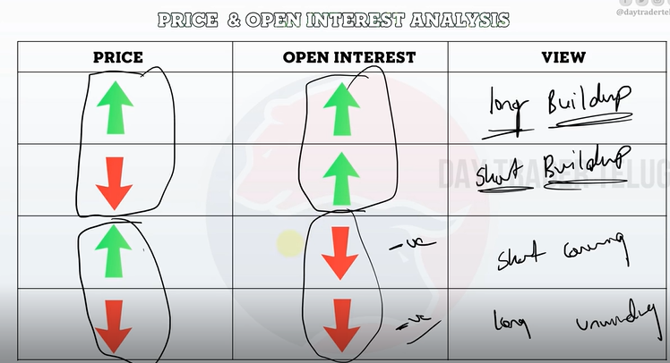

### **Importance of Open Interest in prediction**

If the open interest is positive in

1. buy side (long buildup), then the bullish view is strong
2. sell side (short buildup), then the bearish view is strong

## point to note

most activity and open interest can be seen in near expiry

greek options will only give direction, but not complete prediction, as there is a lot of volatility and external factors invloved

## how to select stocks for trading

# option chain analysis

chapter 7: <https://youtu.be/_LnMghwJ-fQ>

## why should we learn option chain analysis

we have option chain analysis for stocks which trade in FNO, people who trade in nifty and bank nifty look at option chain analysis

## what is the use of option chain analysis

we can **get an idea about support and resistance** of an index or stock trading in FNO

### advantages of using support and resistance

1. helps us to decide should we enter or wait
2. to know whether market is in range bound or breakout
3. to decide target and stoploss
4. to see if the market is in trending or not

**to understand direction of market**

there might be scenarios where we can see that there is strong candles formation, and good volumes but there is sudden reversal in the movement and market takes reverse direction

also **we can know where we might have the current expiry**

you can view option chain for indexes or stocks in FNO

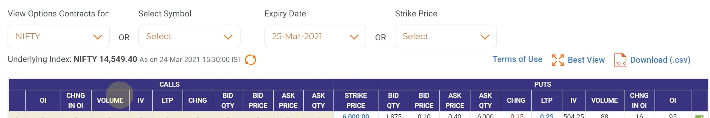**­­**

## Terms in above image

Left is the data for calls and right is the data for puts

link- https://youtu.be/_LnMghwJ-fQ

### OI

You are a option buyer and you want to buy a particular contract, to buy a contract you need a seller too, when a seller sells a contract to a buyer then we can say that a contract is **written**

**OI** is nothing but the count of contracts written

Above OI has the count of contracts **written** right from the opening of the contract to till date

### Change in OI

If the market hours are open, then the contracts written the same day till that moment is change in OI

If the market is closed, change in OI denotes what where the contracts that were written in the recent trading session

It represents the change in the number of outstanding option contracts for a particular strike price and expiry date compared to the previous trading day.

**Change in OI is important because,**

* **if change in OI is positive at a level, that will support the view of existing contracts**
* **if change in OI is negative at an important level (with decrease in underlying scrip value), that indicates that investors are thinking that their opinion is wrong and they are exiting their positions**
  + **also change in oi at a particular level is becoming negative**
    - **at a call level: there is high chance that it is going to break that resistance**
    - **at a put level: there is a high chance that it is going to break that supportusuuuuuu**

### Volume

This denotes number of contracts that have changed hands look the above **price, Open Interest, Volume**

### IV implied volatility

Need to see VIX video? #need_clarity

### LTP

Price at which the last the contract has traded

### CHNG

It represents the change in the price of an option or the underlying asset since the previous day's close. The change is expressed in terms of the absolute value and as a percentage. For example, if the CHNG value for an option is +10.00 and +20.00%, it means that the option's price has increased by 10 points and 20% since the previous day's close. Similarly, if the CHNG value is -5.00 and -10.00%, it means that the option's price has decreased by 5 points and 10% since the previous day's close.

### BID price

Price at which the buyers are trying to buy

### ASK price

The price at which sellers are trying to sell

### BID qty

Quantity which the buyers are trying to buy

### ASK qty

Quantity which the buyers are trying to sell

### Strike price

Already discussed earlier in this document

### An example

Below is the option chain for strike price 15000





## How we understand Open Interest





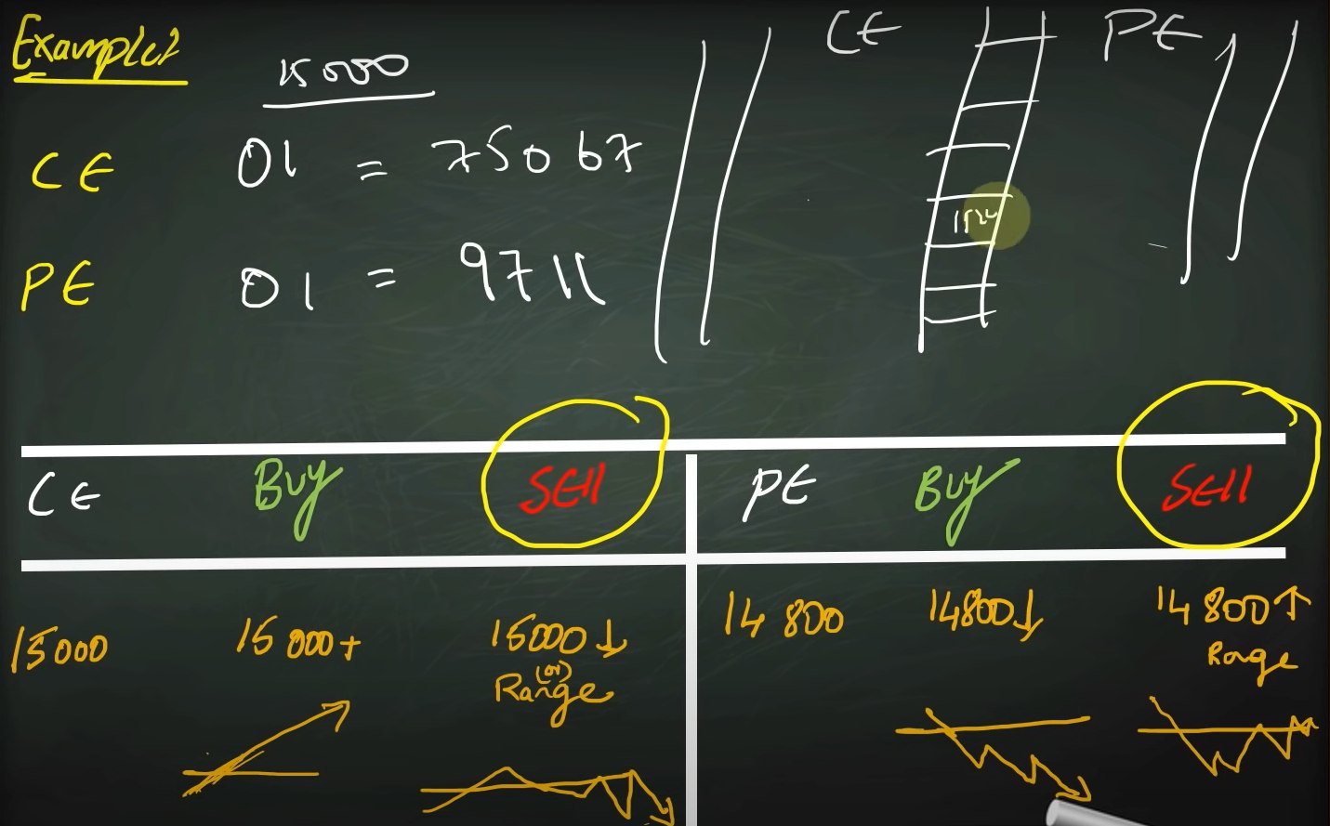

Let’s say we have OI 75067 for 15000CE, that is the highest OI, 75067 OI means those many contracts are written (sold by option sellers)

### We prefer to take seller side

Seller has

* unlimited risk
* limited profit
* more money need
* sellers are most of the times institutional investors

Seller has unlimited risk (for a 15000 CE buyer the maximum down he can have is market at 0, but for a 15000 CE seller, he has to bear unlimited loss if the market keeps going up and up), therefore we prefer the view that an option seller takes

I had this doubt that a put option seller does not loose much because in a put option seller eyes, market will be at range bound or goes up, if that is the case, he does not have much to loose, but I am wrong, what I really should be seeing here is that an option buyer never has the obligation, but an option seller has the obligation, which makes him to loose more

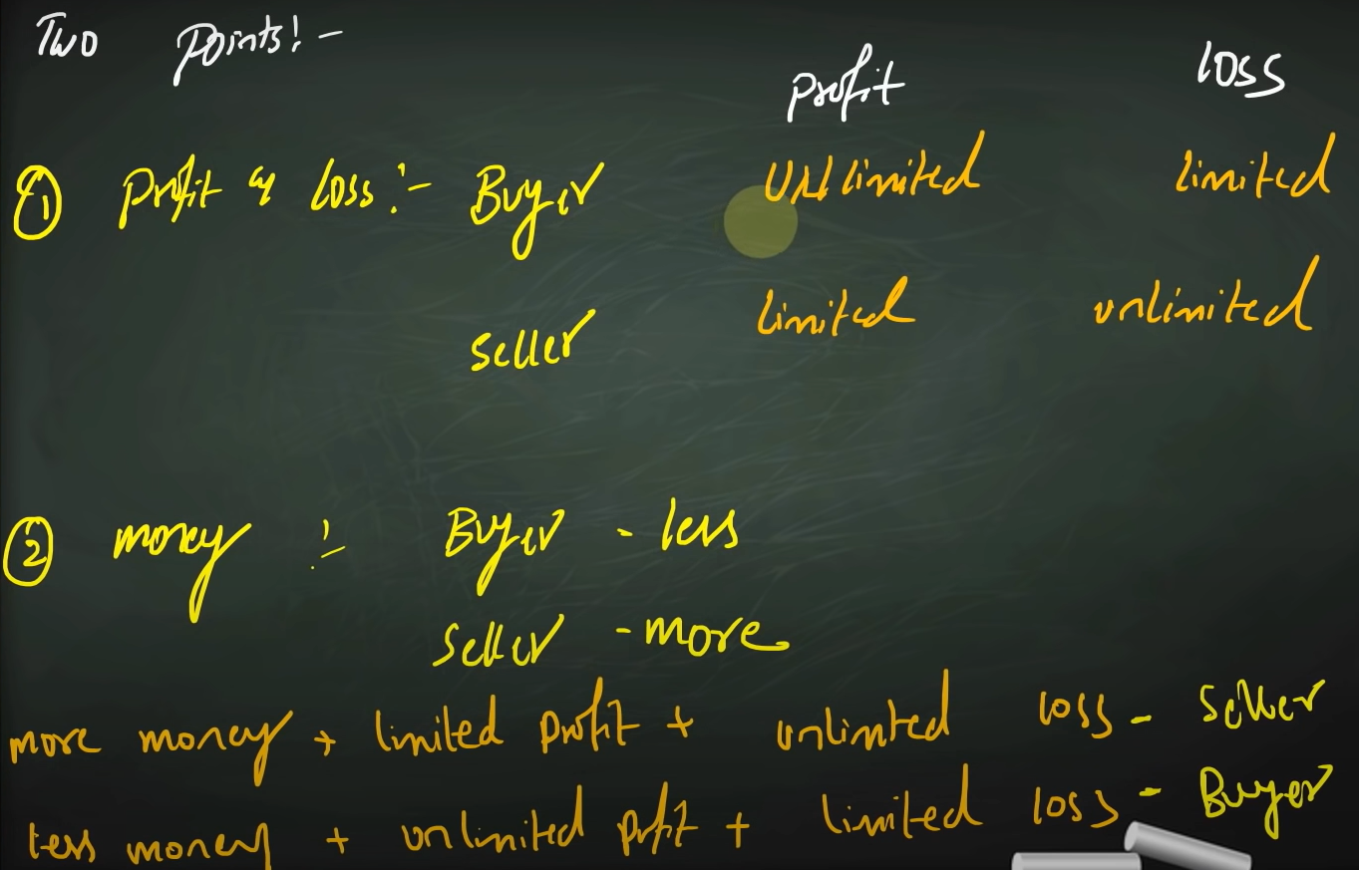

### What is the view of

#### 15000 CE buyer:

He thinks market is going to go above 15000 (bullish view)

#### 15000CE seller:

He thinks market is going to stay at 15000 or going to fall (neutral to bearish view)

#### 15000PE buyer:

He thinks market is going to fall below 15000 level (Bearish view)

#### 15000PE seller:

He thinks market is going to stay at 15000 or move above 15000 (neutral to bullish view)

#### Important question – whose view should we consider?

##### For support

You need to look at where there is more OI at PE side

##### For resistance

You need to look at where there is more OI at CE side

##### Image explanation for above 2 headings

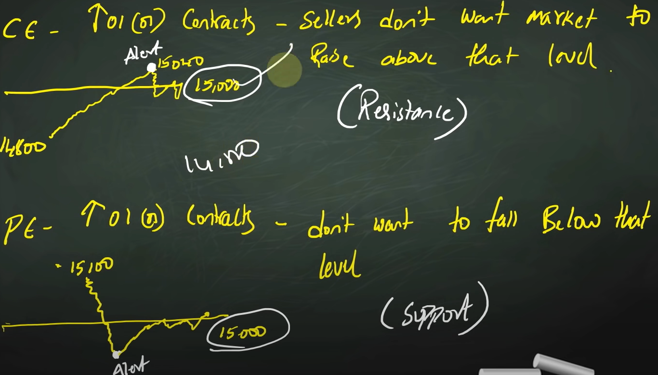

## How we use OI to analyse market

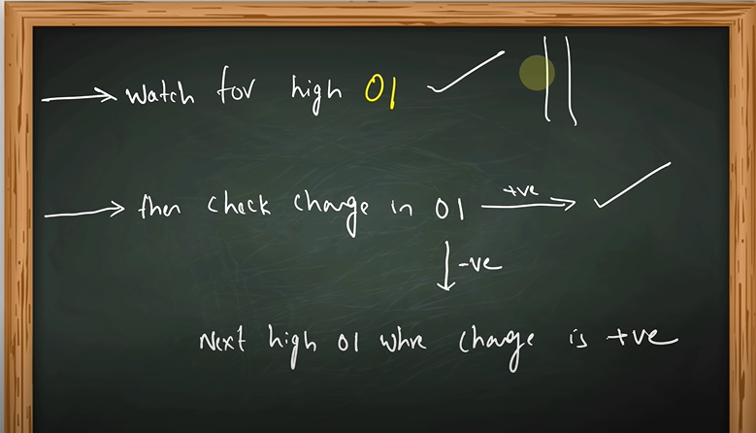

In the below example, we prefer 45,000 level instead of 50,000

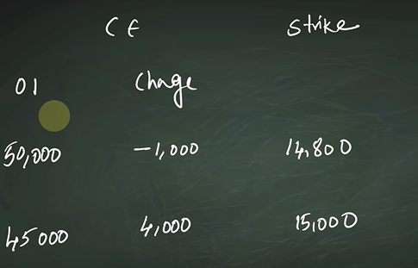

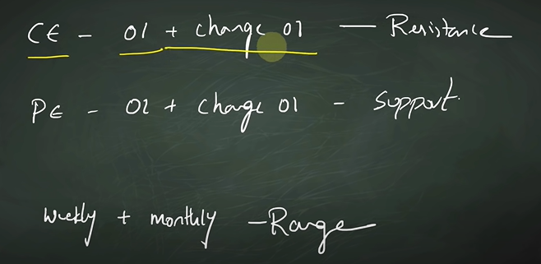

To analyse a stock, we can see the particular monthly contract, and (maybe probably if needed next month contract, but that does not make a significant difference)

To analyse a index, we need to watch weekly and monthly contract (if the current contract is a month end contract, then you can analyse current contract along with, next month first week contract or next month end contract) and see for matching levels

## How should we see negative change in OI in

As we see only seller POV in options

#need_clarity at https://youtu.be/_LnMghwJ-fQ?t=43m13sec

### Call sellers

#### If the market is going down

If a call seller sells 15000 CE and market starts falling down to 14500 CE, as seller can only have the premium he got as profit (a seller can make most money at ITM) as 15000 CE is becoming ATM, he will go to 14500 CE (or a ITM CE which has more OI and change in OI) and sell that

**If the Change in OI is negative at current level (ex-15000) and is increasing at below levels (14800,14500..) then market is bearish**

#### If the market is going up

Let’s say that market is at 15000 and you sell 15000 CE and market moves up to 15200 CE, then CE seller will be in loss and he will move to a higher position and sell 15400 CE or some other contract with **high OI and change in OI**

**If the Change in OI is negative at current level (ex-15000) and is increasing at higher levels (15200,15300..) then market is bullish**

### Put sellers

#### If the market is going down

Let’s say that market is at 15000 and put seller thinks that market will be at 15000 range and sells 15000 PE, but if the market starts falling down to 14500 then 15000 PE becomes ITM and as market is going in the opposite direction, put seller will exit his position and further go in and sell at a lower level, if it still goes down, then seller further goes down and sell at a lower strike price,

Unwinding positions at a higher level in put side and forming/writing positions at a lower strike price indicates weak market conditions

**If the Change in OI is negative at current level (ex-15000) and is increasing at below levels (14800,14500..) then market is bearish**

#### If the market is going up

Let’s say that market is at 15000 and put seller thinks that market will be at 15000 range or moves up and sells 15000 PE, if the market moves up to 15200 then 15000 becomes OTM and premium falls, then seller will move to a higher level(ATM) and sell there

**If the Change in OI is negative at current level (ex-15000) and is increasing at higher levels (15200,15300..) then market is bullish**

# Option trading with less money

Chapter 8

9th Link: <https://youtu.be/r7Cm_NU_G9A>

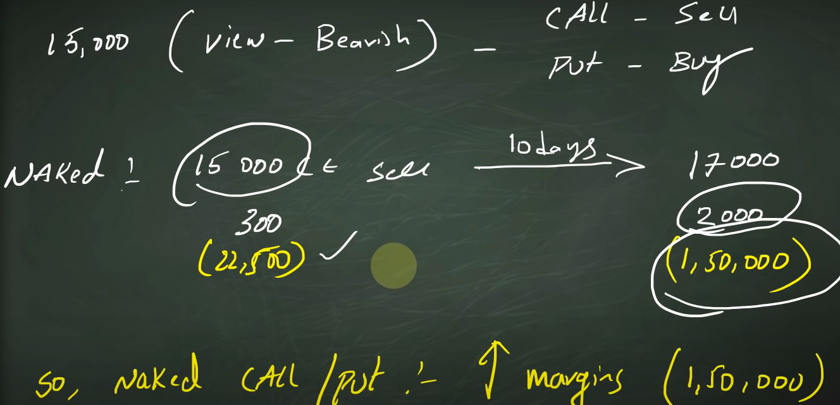

## For call sellers

Let’s take an example of above image, you think that market is at 15000 and it is going to fall, then you can sell call option or you can buy put option

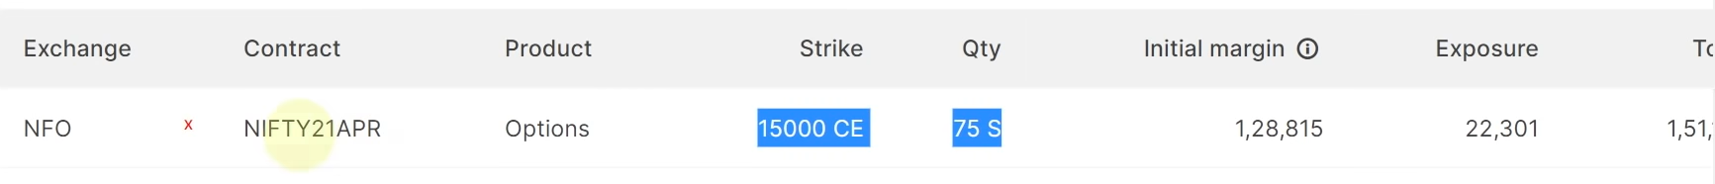

And we assume that you had sold 15000 CE option (thinking that you will get 300*75 = 22500) and in 10 days market reached 17000 so you are at loss of 150000 so brokers ask more money if you do naked sell call/put option (selling an option contract without any security)

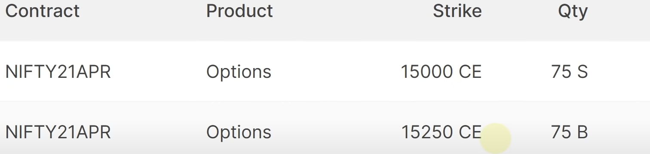

To avoid naked option, you can sell 15000CE and buy 15100 CE or 15200 CE or 15300 CE or 15400 CE or 15500 CE or 15600 CE

Below image shows how will you be affected if you buy which call option contract to avoid naked option

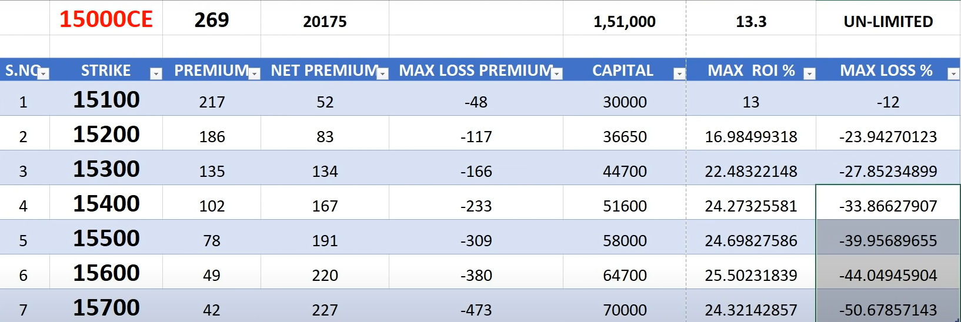

If you buy naked option the loss is unlimited.

### Points to note:

Net Premium = 15000CE sell premium – your buy premium

= for example- if you buy 15100 the premium you get is 269-217=52

Max loss premium= Premium - (buy strike-sell strike)

= for example- if you buy 15100 -> 52 - (15100-15000) = -48

After a level max ROI% stagnates, but max loss will keep increasing

The capital you need increases with your buy option strike price

## For put sellers

Same is the case for put sellers

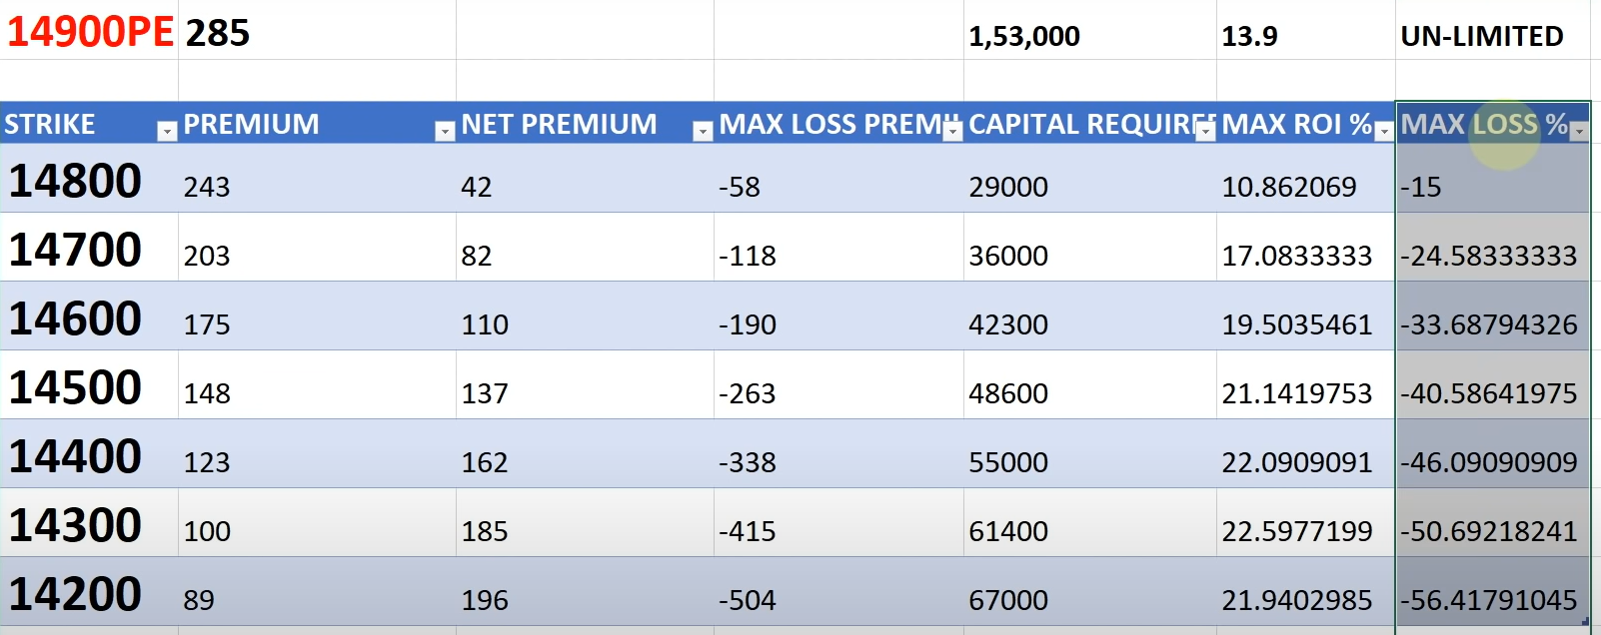

## Important point to note

If we have so many options in the above table, then which option to buy to avoid being a naked sell:

If you sell a option contract at x premium, buy a option with x/2 premium at least

# Live options trading

Chapter: None

10th link: <https://youtu.be/fRJMuZ8kc-8>

Two ways in which profit is earned generally in stock market

## Way 1:

Buy at a lower price

Sell at a higher price

## Way 2:

Sell at a higher price

Buy at a lower price

## important terms in options

#### note

not all the stocks and indices has futures/options

### Call

Also called as CE

Its value is proportional to underlying asset

* Increases with increase in underlying asset
* Decreases with decrease in underlying asset

### PUT

Also called as PE

Its value is indirectly proportional to underlying asset

* Increases with decrease in underlying asset
* Decreases with increase in underlying asset

### Strike price

Let’s take an index (nifty) as example

If nifty is at 18000 level and you want to buy a call option of 18200, then 18200 will be the strike price

### Spot price

The price at which the **index/stock is trading** is called spot price.

### Future price

Stocks/indices will have a future trading for different expiry dates, the price at which the future contract is trading is called future price.

### Expiry

Every future or option contract has an expiry date, post which the contract holds no value

#### Stocks

Stocks have monthly expiry and expiry date will be last working Thursday

#### Index

Indexes have monthly and weekly expiry and expiry date will be last working Thursday

##### Important note

If last working Thursday is holiday, then the working day before it will be expiry date.

More money is required for monthly contracts, because you will be having more time when it comes to monthly contracts.

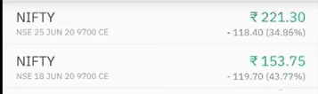

https://youtu.be/fRJMuZ8kc-8?list=PL_Bj8MwxMrhpO3liO_QRS3Kl5SDnMPINs&t=635

# Misc

* All shares are not in FNO, if a share is in derivative, then they have both FNO as they are interrelated
* Even indexes, metals, currencies have FNO

# Hashtags

Topics that are needed clarity - #need_clarity

Topics that need extra info - #need_enhancement

Need real time scenario experience/ knowledge - #need_to_check_in_realtime

#last_stopped last stopped

#need_to_write

Last date - 26/2/23